4-6: Drought
Drought is a deficiency of moisture that results in adverse impacts on people, animals, or vegetation over a sizeable area (NOAA National Weather Service) or a period of abnormally dry weather sufficiently long enough to cause a serious hydrological imbalance (American Meteorological Society). It is a complex phenomenon that is difficult to monitor and assess because it develops slowly and covers extensive areas, as opposed to other disasters that have rapid onsets and obvious destruction. The effects of drought can linger long after the drought has ended. The northeast United States can also experience “flash” or rapid-onset droughts with intense dry periods of about 2 to 6 months followed by a period of above-normal precipitation.

Drought is an inherent, cyclical component of natural climatic variability and can occur at any place at any time. High winds, low humidity, and extreme temperatures can all amplify the severity of the drought. It is difficult to determine the onset, duration, intensity, and severity of a drought, all of which affect the consequences and corresponding mitigation techniques. The different types of drought have different corresponding impacts on people and our environment.

Types of Drought:

- Meteorological: a reduction in rainfall from a normal precipitation pattern in regard to the amount, intensity, or timing of the event as well as changes in the temperature, humidity, and wind patterns. The strict threshold differs for every nation; the United States defines meteorological drought as receiving less than 2.5mm of rainfall in 48 hours. Meteorological drought is the first drought stage detected.
- Agricultural: deficient moisture conditions that cause a lasting effect on crops and non-natural vegetation. It is dependent on rainfall, temperature, topography, evapotranspiration, permeability, and porosity of soils, precipitation effectiveness, and vegetative demand. Agricultural drought begins when the available soil moisture supports the actual evapotranspiration rate at only a fraction of the potential evapotranspiration rate.
- Hydrological: related to the effects of decreased precipitation on surface or subsurface water supply. It is the last stage of drought and is lagged behind meteorological and agricultural drought because water infiltrates down to the groundwater during the latter portion of the hydrological cycle. Subsurface water supply is the last drought component to return to normal when meteorological conditions and aquifer recharge return.
- Socioeconomic: what happens when the consequences of the drought start to affect the socioeconomic sector. It occurs when the demand for an economic good is greater than the available supply due to weather-related drought. Examples of such goods include water, hydroelectric power, food grains, meat, dairy, and much more. Socioeconomic drought affects the associated population both individually and collectively.
- Ecological: defined as “a prolonged and widespread deficit in naturally available water supplies — including changes in natural and managed hydrology — that create multiple stresses across ecosystems.” More info on Ecological drought: https://snappartnership.net/teams/ecological-drought/.

The severity of a drought depends on the duration, intensity, and geographic extent of the water shortage, as well as the demands on the area’s water supply. Droughts are rated in classifications from D0–D4, depending on the severity of the drought, the amount of time it will take for vegetation to return to normal levels, and the possible effects of the drought on vegetation and water supply (Table 34).

Drought differs from other natural hazards in multiple ways. First, drought is not as obvious as other hazards; it does not have the property destruction of a tornado or hurricane nor the apparent ecological destruction of a wildfire. Second, there is a lack of an exact and universally accepted definition of drought. Finally, the beginning and end of a drought is difficult to determine: though the surface water content may have recovered from a period of drought, the replenishment of groundwater levels is a longer process. In addition, droughts are often spread over a larger geographic area than other natural hazards. These things considered, the economic effects of a drought can be just as devastating as any other natural hazards.

Table 34: Drought Severity Classification
Category | Description | Possible Impacts
D0 | Abnormally Dry | Going into drought:  short-term dryness slowing planting, growth of crops or pastures  Coming out of drought:  some lingering water deficits  pastures or crops not fully recovered
D1 | Moderate Drought | Some damage to crops, pastures  Streams, reservoirs, or wells low, some water shortages developing or imminent  Voluntary water-use restrictions requested
D2 | Severe Drought | Crop or pasture losses likely  Water shortages common  Water restrictions imposed
D3 | Extreme Drought | Major crop/pasture losses  Widespread water shortages or restrictions
D4 | Exceptional Drought | Exceptional and widespread crop/pasture losses  Shortages of water in reservoirs, streams, and wells creating water emergencies
Source: http://droughtmonitor.unl.edu/AboutUSDM/DroughtClassification.aspx
Location
Though Vermont encompasses a small geographic area, the State has distinct regions that can experience significantly different weather patterns and react differently to the amount of precipitation they receive. According to the U.S. Drought Monitor’s archived data, the southeastern portion of the State is more vulnerable to prolonged periods of more significant drought, likely due to its lower elevation and landlocked location.

Drought History

Vermont has a highly variable, unpredictable climate. Droughts, while low frequency hazards, are of serious concern to the population of Vermont. It is often difficult to recognize the onset of a drought during its preliminary stages, and together with Vermont’s variable climate can lead to the disregard for the seriousness of an oncoming drought. Even though the State usually has adequate rainfall, droughts occasionally occur. Several severe droughts have been recorded during the last century, while moderate and mild droughts are much more common. The droughts in the mid-1960s were the most severe in Vermont. Every county in the State experienced Exceptional Drought (D4) conditions in May of 1965 (Figure__). Since the 1960s Vermont has experienced several less severe periods of drought (Figure __).

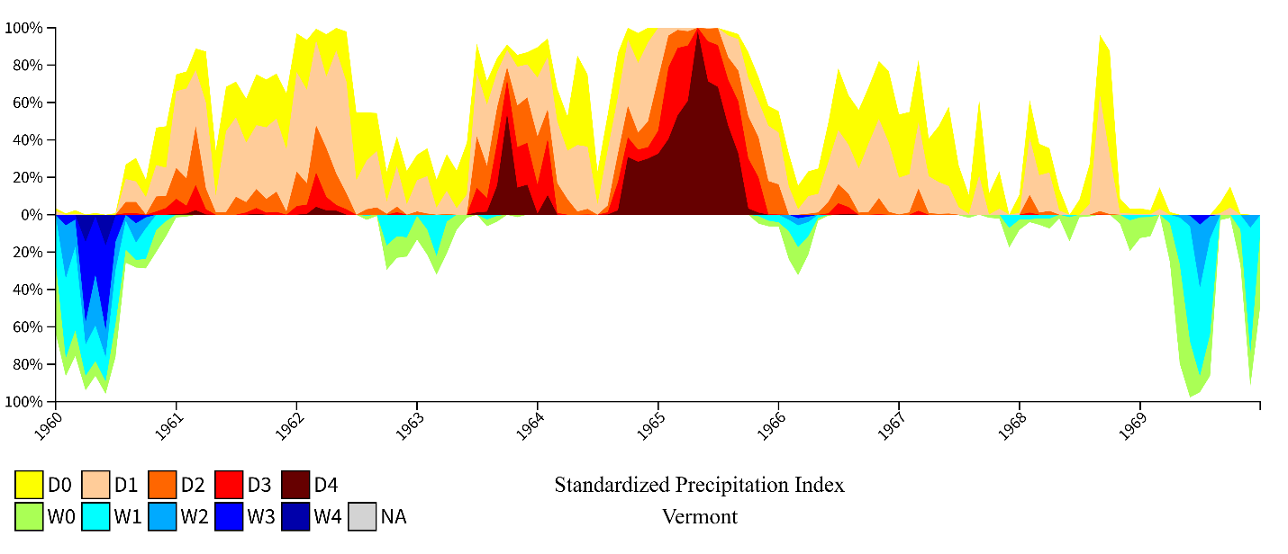
Figure ___: Standardized Precipitation Index, Vermont 1960 to 1969.

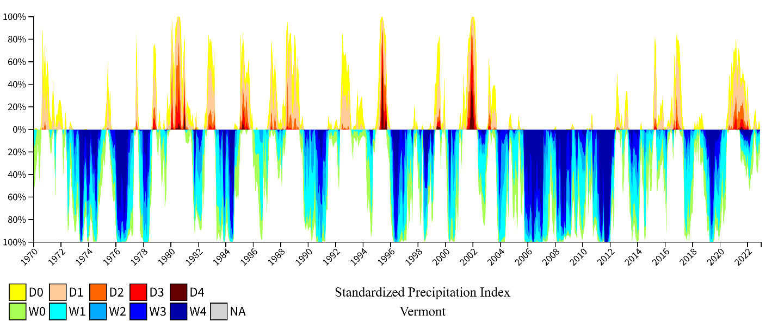
Figure _: Standardized Precipitation Index, Vermont 1970 to 2022

There were two declared statewide droughts in June and July 1995. These droughts were due to a lack of rainfall, which required officials to put restrictions on water usage. Lack of rain combined with some of the highest temperatures led crop loss in some areas. The drought persisted through the summer of 1995, and a third, more severe drought affected Southern Vermont in August of that year. From 1998 to 1999 parts of the state in Chittenden and Franklin Counties experienced Exceptional Drought (D4), and much of the state experienced Moderate Drought (D1) or Abnormally Dry conditions (D0).

In 2001-2002, Vermont was affected by a Severe Drought (D2), which peaked at over 14% of the State at the D2 level between November and December of 2001 and nearly 100% of the State in at least Moderate Drought (D1) (Figure 53). In response to the 2001-2002 drought, the Vermont Agency of Natural Resources Drought Plan was developed in consultation with VEM to guide its activities in response to droughts and extended periods of dry weather. The plan is a set of operating procedures that outline the responsibilities of various programs, lines of communication to be used, and the general sequence of actions to be followed based on the severity of the situation. Additionally, the plan provides a set of qualitative and quantitative Vermont-specific drought severity indices and recommended actions based on drought level. This drought section has been part of the State Emergency Operations Plan since 2013.

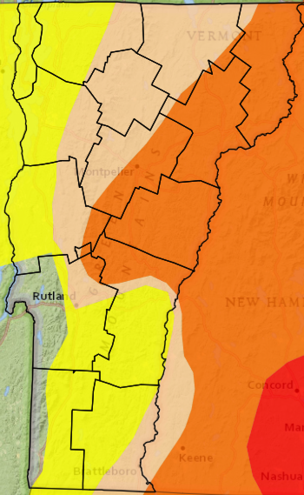
In late summer/early autumn of 2007, ground water shortages were evident in several areas of Vermont. This was particularly apparent near shallow wells.

Portions of Vermont were in Severe Drought (D2) from October 2016 through April 2017, peaking at 29.15% of Vermont in October and November 2016 and 80% of the State was in at least Moderate Drought (D1) (Figure 53). Moderate Drought conditions returned in October of 2017 and again in June 2018. From September to November of 2018 the State experienced another Severe Drought. Then from June 2020 to October 2021 much of the State was under Moderate Drought to Abnormally Dry conditions. From September to October of 2020 29.4% of the State was under Severe Drought conditions.

Figure__: USDM October 6, 2020

[Fig 53, map of abnormally dry to severe drought in the 2001 drought]

Drought Trends

Relative to other regions of the country, severe droughts are not frequent occurrences in Vermont. However, floods and droughts are respectively two of Vermont’s highly likely and likely natural disasters. Vermont’s precipitation trend is an on upward trajectory, having seen increases in average annual precipitation of 7.5 inches since 1900. At the same time Vermont is seeing an increase in average annual maximum and minimum temperature (see: Extreme Temperature), which is contributing to an increased likelihood of drought. Higher temperatures lead to increased rates of evaporation, combined with dry periods between intense precipitation events will lead to increased dry conditions. The wet and dry extremes are expected to increase over time in Vermont.

The U.S. Drought Monitor (USDM) started in 2000, and with it came updated methods of drought reporting so that a separate dataset is available for drought conditions since 2000. The USDM relies on drought experts to synthesize the best available data and work with local observers to interpret the information. Prior to 2000 droughts were characterized by Standardized Precipitation Index (SPI). Figure __ displays the USDM drought dataset available since 2000. From 2001 to 2002, 2016 to 2017, 2018 to 2019, and 2020 to 2023, New England experienced historic drought conditions not seen since the 1960s. From 2000 to 2018, there had been two Severe Droughts (D2) droughts in Vermont. Since 2018 there have been three Severe Droughts.

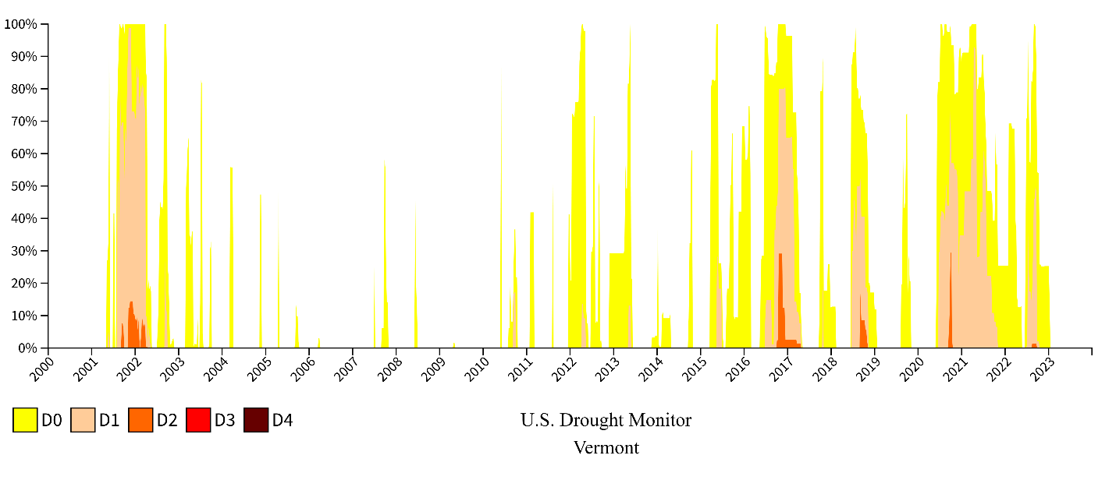
Figure ___: U.S. Drought Monitor, Vermont 2000 to 2023

The occurrence of several D2 (Severe Drought) events in the 21st century, with increased occurrences in the latter half of the 2010s, led the Steering Committee to consider the probability of a plausibly significant drought event to be “Likely”, therefore receiving a Probability score of 3. The Steering Committee’s projected potential impacts were considered to be “Minor” or “Moderate,” receiving a score of 2.5.

Vulnerability
People
The impacts of drought are typically felt by rural residents first. Drought can cause extensive damage to gardens, agricultural crops and livestock. Drought can also lead to dry or low water levels in wells needed for drinking water. Low water levels often do not just mean that an individual, family, or shared home has a threatened water supply, but can also concentrate water contaminate levels and lead to resulting in potential health concerns. The USGS estimates that 97% of the rural population of the United States receives their drinking water through groundwater pumping, where access to municipal/village water is unavailable. The Vermont State Climatologist and Vermont State Geologist have been working together to secure funding to map the State’s groundwater resources to better understand statewide vulnerability to the hazard. The need for these data are expressed both in this Plan (see: Mitigation Strategy) and the 2018 Vermont Groundwater Management Plan. From the Drinking Water and Groundwater Protection Division in the DEC. Drought impacts on people are further discussed under Built Environment, Natural Environment, and Economy.

Built Environment
Structural impacts of drought are very uncommon, making the risk to State buildings, facilities, infrastructure, or governmental functions low. Trends of increased periods of drought may require the construction of new community water supplies with better storage capability and drilling new deeper wells on properties where wells have run dry. As water levels in underground aquifers fall, the ground runs the risk of subsidence. Subsidence is the sinking of the ground which can impact roads, buildings, and water pipes, and can lead to the formation of sinkholes.

Natural Environment
The impacts of drought to the natural environment can be extensive. Soil moisture, streams, and groundwater are all depleted due to drought. Drought depletes water availability for both cultivated and wild plants and animals. As a result of the 1998 to 1999 drought, tens of millions of dollars’ worth of hay, corn, and other crops were lost. During past droughts in Vermont, deciduous trees have experienced leaf scorch, leaf yellowing, and early leaf color, which is not just a symptom of poor tree health, but also subdues fall foliage color that “leaf peeping” tourists travel from out of state to see. The effects on trees are visible both in forested and urban or suburban areas. Impacts of drought are projected be more severe for urban trees because of the effects of the built environment on temperature and water cycling. Drier forests are also more prone to wildfire (see: Wildfire). Less visible effects of drought on ecosystem imbalance can lead to species decline and extinction. For example, vernal pools may dry before reproductive cycles of pool-breeding amphibians have completed.

Economy
The economic impact of a significant drought event is greater than the risk to life or property. Though dollar losses from droughts are not estimated to date, certain losses could be investigated. Drought has effects on the economy in all seasons. In warm weather we can expect decreased agriculture and forestry production, impacts to surface water supplies and fisheries, costs associated with the construction of new community water supplies with greater storage capacity and individual or community wells that have been deepened to capture additional yields. In the forestry industry drought can negatively impact forest stock by increasing mortality and reducing growth. A reduced vegetative cover can also increase the impacts of wind and water erosion(see: Wind and Inundation Flooding and Fluvial Erosion). In the fall drought effects may cause declines in “leaf peeping” tourism due to subdued color. In the winter drought can impact precipitation in the form of snow, leading to stresses on winter recreation businesses. In the spring, loss of snowpack can leave trees vulnerable to the cold impacting maple product production as well as reducing early season water availability vegetation would have received from a melting snowpack.

Drought Current Capabilities and Mitigation

The Drinking Water and Groundwater Protection Division in the DEC published a Groundwater Management Strategy in 2018 to help ensure adequate quantity and quality of groundwater, including during periods of drought. The Office of the State Geologist develops groundwater resource maps for towns and conducts ongoing statewide assessments to help towns plan for adequate supply. The resources this program provides are intended for community planning purposes, so that future water supplies can be sited. Communities with groundwater wells that have adequate yields in times of drought have a degree of protection, where low yield areas may be more vulnerable.

The 2018 Vermont Groundwater Management Plan identifies groundwater protection as a necessary precaution to minimize vulnerability to future fluctuations in groundwater levels due to both anticipated increased precipitation and prolonged drought periods. The plan goes further to note that while groundwater protection is an issue understood at the local, regional, State and Federal levels, careful consideration of it only takes place during times when problems with groundwater levels may arise.

The Best Management Practices Program (6 V.S.A. § 4821) offers the potential to create opportunities for drought protection practices such as irrigation and on farm water storage. Water monitoring is also vital for other sectors beyond residential and agricultural use, as the recreational and tourism sectors can be negatively impacted by the occurrence of a drought.

As noted above in Drought Trends & Vulnerability, the Vermont State Climatologist and State Geologist have been pursuing grants to secure funding for groundwater resource mapping. Knowing where the State’s groundwater resources are located is considered critical information, necessary to understand the State’s vulnerability and then to develop mitigation actions and strategies aimed at reducing drought vulnerability. A drought plan for Vermont, groundwater resource mapping, expansion of the number of monitoring wells across the State and a thorough analysis of water level monitoring data have been identified as mitigation actions under the 2023 SHMP’s “Promote Drought Resilience” strategy (see: Mitigation Strategy). This strategy also supports increasing the capacity for monitoring surface water supply and quality, assisting local communities in water systems and lines to determine alternative water sources to wells, and increased coordination between State and Federal resources and funding around monitoring and mitigation against drought. Further, the 2018 Vermont Groundwater Management Plan identifies “exploring partnerships with FEMA to fund water data acquisition related to drought” as part of its long-term approach to increasing the State’s understanding of and resilience to the hazard.

The Vermont Drought Task Force, made up of representatives from several State and federal agencies, is convened quarterly to discuss current drought conditions, share drought-related information, identify data gaps and needs and develop conservation guidance to all citizens, when applicable. The Task Force developed the Drinking Water Drought Reporter online tool, which allows the Agency of Natural Resources to compile drought data and identify areas vulnerable to drought impacts.
[Fig 54, ANR drinking water drought reporter map]

http://drought.unl.edu/DroughtBasics/TypesofDrought.aspx
https://statesummaries.ncics.org/vt
https://www.drought.gov/historical-information?state=vermont&dataset=1&selectedDateUSDM=20110719&selectedDateSpi=19990701&dateRangeSpi=1998-1999
http://drought.unl.edu/archive/plans/drought/state/VT_2005.pdf
https://site.uvm.edu/vtclimateassessment/files/2022/08/VCA-entire-8-3-22-web.pdf
https://www.drought.gov/dews/northeast
https://water.usgs.gov/edu/droughtandgw.html
NIDIS Navigation and Transportation https://www.drought.gov/sectors/navigation-and-transportation#:~:text=When%20water%20supplies%20are%20depleted%20in%20drought%2C%20subsidence%20(the%20sinking,to%20the%20formation%20of%20sinkholes.
Michael Toussaint, July 2001 and Jeffery Carter, August 1999 as cited by Dupigny-Giroux, L.-A. (2002) “Climate variability and socioeconomic consequences of Vermont’s natural hazards: A historical perspective,” Vermont History, Volume 70, Winter/Spring, pp. 19-39. https://vermonthistory.org/journal/70/vt701_204.pdf
Sandra Wilmot, November 1999 as cited in Dupigny-Giroux, L.-A. (2002).
Vermont Climate Assessment. https://site.uvm.edu/vtclimateassessment/files/2022/08/VCA-entire-8-3-22-web.pdf
Weather-Related Effects On Woodland Vernal Pool Hydrology And Hydroperiod https://www.fs.usda.gov/ne/newtown_square/publications/other_publishers/OCR/ne_2004brooks01.pdf
https://www.fs.usda.gov/ccrc/topics/effects-drought-forests-and-rangelands#:~:text=Economic%20Consequences%20of%20Drought&text=Droughts%20can%20negatively%20impact%20forest,to%20wind%20and%20water%20erosion.
http://dec.vermont.gov/sites/dec/files/dwgwp/DW/2018%20Groundwater%20Management%20Plan.pdf
http://dec.vermont.gov/sites/dec/files/dwgwp/DW/2018%20Groundwater%20Management%20Plan.pdf
https://anrmaps.vermont.gov/websites/droughtreporter/

