
Vermont Emergency Management

RACES EMERGENCY
COMMUNICATIONS PROGRAM

Healthcare Emergency Communications
Network

TO ACTIVATE THE VEM RACES HEALTHCARE EMERGENCY COMMUNICATIONS NETWORK
CALL VEM AT:

1-800-347-0488 (24 HRS)

OR

CONTACT YOUR LOCAL
RACES REPRESENTATIVE

May 1, 2017

Issuing Officer: Jason E. Gosselin, Operations and Logistics Section Chief

Radio Amateur Civil Emergency Services
http://VEM.vermont.gov/programs/races
1-800-347-0488
VEM RACES Healthcare Emergency Communications Network

Standard Operating Guide

May 1, 2017

The information presented in this Standard Operating Guide is specific to the Healthcare Emergency Communications Network Program, and augments guidance outlined in the VEM RACES Standard Operations Guide.

VEM-RACES Activation and Location of Operations

VEM will activate RACES Personnel at the request of the local Emergency Management Director (local EMD). This may be initiated via telephone, email, text message, radio or pager. In the
case of Local Activation, the Member will inform the VEM Watch Officer (800-347-0488) of the Activation and receive approval prior to deployment.

Since RACES serves the government with a means of auxiliary communications, it is vital that RACES radio operators be available at the Emergency Operations Center or local command post, as requested by VEM or the local EMD. The local EMD or VEM will determine additional deployment of RACES operators. In most situations, RACES operators will be working "in the field," and not from their homes.

Activation Procedures

- Hospital or Vermont Department of Health (VDH) requests to VEM. In circumstances where a hospital or VDH requires RACES communications, the local RACES representative and VEM Watch officer may be contacted to request assistance. The VEM 24 hour contact number is 1-800-347-0488.

- Local EMD request to RACES. In circumstances where a local EMD requires RACES communications, the local EMD shall contact their local RACES member and the VEM Watch officer for immediate assistance. The VEM 24 hour contact number is 1-800-347-0488.

- Statewide RACES activation from VEM. In circumstances where a regional or statewide RACES activation is warranted, VEM may request a hospital(s) or VDH RACES station be staffed.

RACES Member Identification

Each member will have been issued a Vermont VEM RACES Identification Card. This is
the ONLY identification to be accepted by state or local Emergency Management
Directors and personnel for entry into secure areas. The RACES Identification Card shall display: the member’s Name, FCC Amateur Call Sign and Operator Class, County of Residence, a photograph, Issuance and Expiration Dates, and Signature of VEM RACES Radio Officer.

Each RACES operator will always be able to provide a valid VEM RACES ID when activated and deployed.

Insurance for Members during an Activation

VEM RACES members when activated are acting as agents of the State of Vermont and
are covered under Vermont liability and workman’s compensation insurance. The VEM
Watch Officer (1-800-347-0488) must be informed of the activation in order to invoke this clause under State Statute Title 20 and approval for the deployment must be provided prior to deployment.

Radio Station and Equipment

Each hospital / VDH Office will maintain a dedicated RACES radio system. The radio system has the capacity for local (within the county) and long distance communications across Vermont, New England, Canada, and the United States.

An ICOM 706MKIIG transceiver, AT-180 tuner and requisite power supply comprise the standard equipment installed at all Vermont Hospital and Health Department stations. A digital modem and laptop computer may also be present. Additionally, a RACES Communication Unit trailer may be dispatched to serve as an additional local station with HF, UHF, VHF and digital communications capabilities.

Anderson Power Pole© connectors are RACES standard at all stations in order to facilitate easy use of RACES members’ equipment.

VEM will conduct monthly drills to test the interoperability of the radio system and ensure that radio operator is familiar with hospital / VDH access procedures.

Station Operators

A VEM-RACES Health Care Network station may be operated only by a duly licensed member of VEM RACES or authorized operator for DHS MARS specific frequencies.

When deployed, the VEM RACES program will assign two licensed RACES amateur operators to each of the hospitals and VDH District offices.

Any issues or complaints that may arise from RACES related operations in Health Care Network office settings should be directed to the VEM RACES coordinator or VEM Operations at 1-800-347-0488.

Normally, a RACES member within a local area will be notified by VEM via the VTALERT system or radio network upon activation. RACES members who hear information that suggests a local emergency exists should start monitoring local VHF and UHF Repeaters. If the Member has HF capability, operators should also consider monitoring the RACES 40M and 80M frequencies for additional information. Additionally, Members also may be contacted by the EMD(s) in their areas requesting activation of VEM-RACES. In this instance, operators should immediately contact the VEM Watch Officer or RACES Coordinator in Waterbury at 800-347-0488.

Operating Area

VEM-RACES Nets are Vermont-only nets. VEM controls RACES communications only within Vermont. Should you receive communications from stations outside of Vermont, they are not to be deemed official VEM-RACES communications, but rather informational only. If you have questions regarding any non-Vermont communications, please direct inquiries to VEM-RACES net control.

Frequencies

VEM RACES Primary Frequencies:

UHF The state-wide NFMRA linked repeater system is used. Currently networked repeaters are:

444.600+ (PL 110.9) Williamstown
444.650+ (PL 110.9) Monkton
444.700+ (PL 110.9) Newfane (for Brattleboro and Windham County)
444.050+ (PL 100.0) Mt. Equinox (for Bennington County)
444.550+ (PL 110.9) Killington
447.175- (PL 110.9) Mt. Mansfield
448.125- (PL 110.0) Mt. Ascutney

VHF 146.520 Simplex Calling
146.535 Simplex Chatter
146.550 Simplex “RACES 1”
146.565 Simplex “RACES 2”

HF 3,980 kHz [+/- 5 depending on activity] 80 meters
7,280 kHz [+/- 5 depending on activity] 40 meters

Message Traffic

VEM State Emergency Operations Center (SEOC) will normally operate from Waterbury (primary) or Camp Johnson (alternate). There may be additional locations specified for RACES operators. Every RACES transmission will be tracked utilizing standard ICS and VEM Forms shown below, and will be identified in the upper right hand corner as follows:

Location Identifiers and Message Numbering

Before sending a transmission, the operator will write a Prefix and Message Number in the upper right hand corner of the VEM Form. The prefix identifier will be from the list below or the first three letters of the name of the town where the RACES communication originated. Message numbering will be a sequential number, i.e. 1 through 100.

For instance from Waterbury, it would be: “WR-1.”

Vermont Hospital Identifiers

- BMH (Brattleboro Memorial Hospital)
- CVH (Central Vermont Medical Center)
- COPLEY (Copley Hospital)
- FAHC (Fletcher Allen Health Care)
- GMC (Gifford Medical Center)
- GCH (Grace Cottage Hospital)
- MAH (Mt. Ascutney Hospital and Health Center)
- NCH (North Country Hospital)
- NVRH (Northeastern Vermont Regional Hospital)
- NMC (Northwestern Medical Center)
- PMC (Porter Medical Center)
- RRMC (Rutland Regional Medical Ctr.)
- SPH (Springfield Hospital)
- SVMC (Southwestern Vermont Health Care)
- VA (VA Medical and Regional Office Center)
- BR (Brattleboro Retreat)

For example “ BMHR-1”

Vermont Department of Health District Office Identifiers

- VDH BA (VDH Barre)
- VDH BE (VDH Bennington)
- VDH BR (VDH Brattleboro)
- VDH BU (VDH Burlington)
- VDH MI (VDH Middlebury)
- VDH MO (Morrisville)
- VDH NE (Newport)
- VDH RU (Rutland)
- VDH STA (St. Albans)
- VDH STJ (St. Johnsbury)
- VDH SP (Springfield)
- VDH WRJ (White River Junction)
- VDH HQ – (VDH Central Office)
- VDH LAB – (VDH Health Lab)

For example “VDHBAR-1”

The identifiers will be recorded in the RACES station COMM Log, form ICS 309. Examples:
WR-1, VEM Form # 6, or
WR-1, VEM Form # 3, or
WR-1, VEM Form # 1

The VEM Log Sheet will require the RACES Identifier. Examples:

WR-1 (VEM Form # 6) sent to K1KU, by W1DEC at 0000 EST, or,
WR-2 (VEM Form # 5) sent to K1KU by W1DEC at 0020 EST, or,
WR-3 (VEM Form # 2) sent to K1KU by W1DEC at 0035EST

FCC rules require proper message and station logs.

During a drill, every transmission shall start and end with the following language:

“This is a RACES Drill.”

General Message ICS 213 OS

Used by:

- Incident dispatchers to record incoming messages that cannot be orally transmitted to the intended recipients.
- EOC and other incident personnel to transmit messages via radio or telephone to the addressee.
- Incident personnel to send any message or notification that requires hard-copy delivery to other incident personnel.

Form VEM-11 Emergency Operations Center Message

In addition, form VEM-11 Emergency Operations Center Message Form may be used interchangeably with ICS 213 OS.

Communications Log ICS 309

The Communications Log may be used to record telephone or radio traffic when other means are not available. It may serve as the only record of communication or tactical actions.

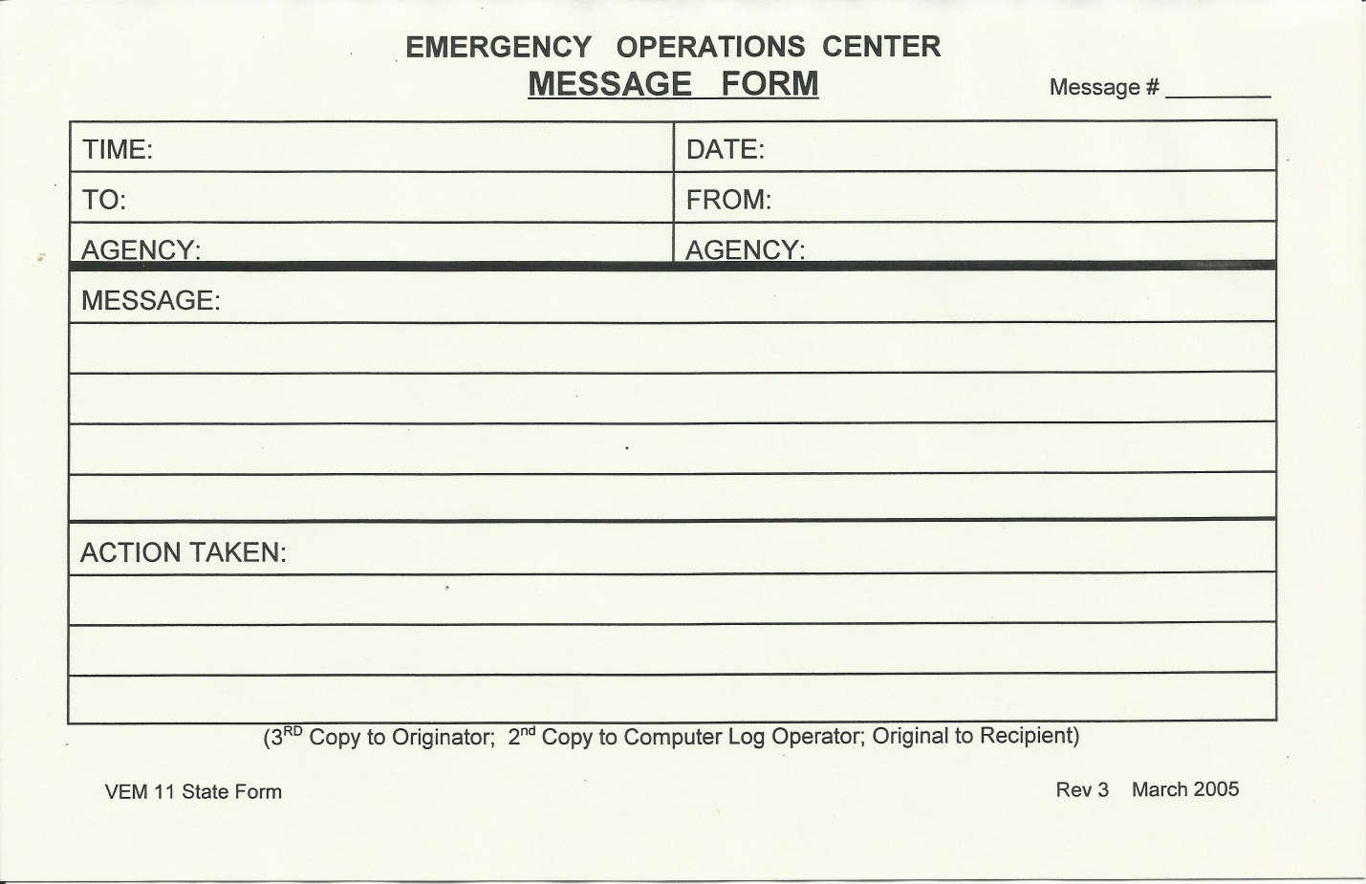

COMPARISON: ICS-213 OS WITH VEM-11

Message form VEM-11 (rev. 2005) is a standard form used by VEM RACES. FEMA ICS-213 OS General Message form, with RACES station message number recorded in the “Incident Name” block, may also be used. Form ICS-213 is standard within the FEMA Incident Command System.

Specific Instructions for Message Form ICS 213-OS and Emergency Operations Center Form VEM-11.

Purpose. The General Message is used by:
- Incident personnel to record incoming messages which cannot be orally transmitted to the intended recipients;
- Command Post and other incident personnel to transmit messages to the Incident Communications Center for transmission via radio or telephone to the addressee;
- Incident personnel to send any message or notification to incident personnel which requires a hard-copy delivery;
- Incident personnel to place resource orders.

Preparation. This form is prepared by any incident personnel needing to transmit a hard-copy message. The recipient should send a timely reply to the originator, as necessary.

Distribution. Upon completion, the General Message may be hand-carried to the addressee or to the incident Communications Center for transmission. Originator retains a copy of the form. All completed original forms MUST be given to the Documentation Unit.

ICS 213-OS  Block: | VEM-11  Block: | Enter:
1 - Incident Name | Message # | Message Number, assigned by Originating Station.
2 - Date and Time of Message | Time;  Date | Date and Time (24 hr. Clock) of Message.
3 - To | To;  Agency | Name and Agency or ICS Position of Message Recipient.
4 - From | From;  Agency | Name and Agency or ICS Position of Message Sender.
5 - Subject |  | The Message Subject.
6 - Message | Message | Message.
7 - Reply |  | To be used by recipient to reply.
 | Action Taken | Notes regarding message disposition (optional).
8 - Signature/Position (Person Replying) |  | Name and Position of person replying to this message.
8 - Date/Time of Reply |  | Date and Time (24 hr. clock) of Reply.
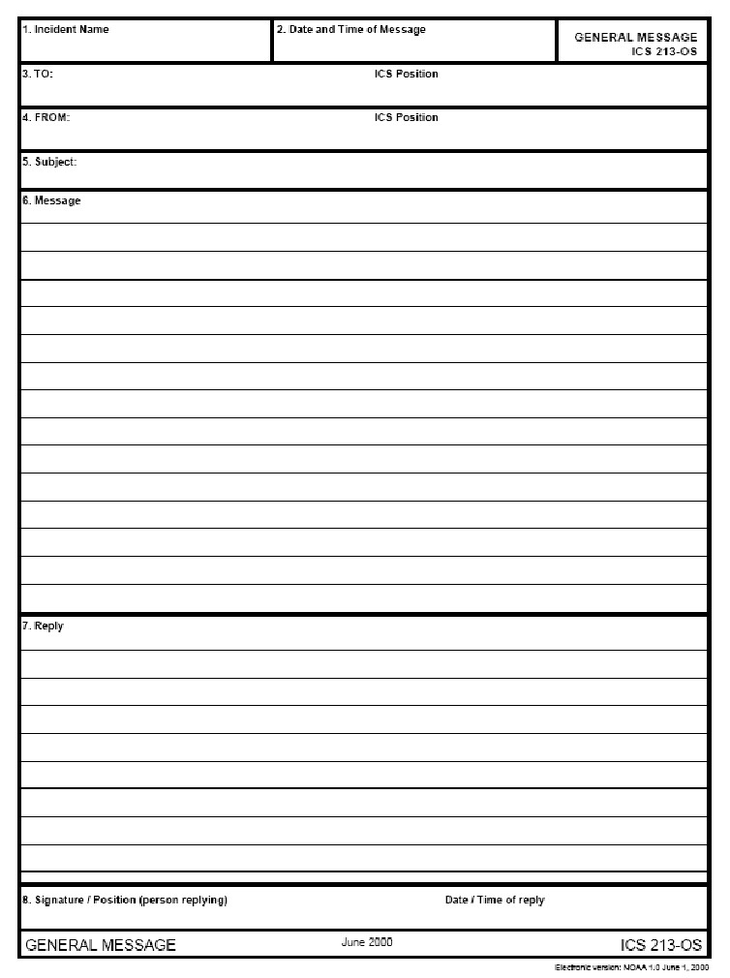

COMM Log  ICS 309  RACES |  | 1. Incident Name and Activation Number |  |  |  |  | 2. Operational Period (Date/Time)  From: To:
3. Radio Net Name (for NCOs) or Position/Tactical Call |  |  |  |  |  | 4. Radio Operator (Name, Call Sign)
5. COMMUNICATIONS LOG
Time  (24:00) | FROM |  |  | TO |  |  | Message
Time  (24:00) | Call Sign/ID |  | Msg # | Call Sign/ID | Msg #
6. Prepared By (Name, Call Sign) |  |  |  |  | 7. Date & Time Prepared |  |  | 8.  Page _____ of _____



