This is a model for an Incident Commander's HAZMAT checklist from the Town of Charlotte. While not mandatory for every LEMP, municipalities with a high risk of HAZMAT spills should have a HAZMAT incident annex and may use this document (or any other format that suits their planning requirements) as a base. Incident plans should be tailored for local conditions, resources, and processes, but are often not used as-is - they are frameworks that can be quickly adjusted during an emergency to provide a usable incident action plan for the actual situation. Delete this paragraph in the final version of this document!
Incident Commander’s Checklist
for Responding to a Hazardous Materials Incident

This Emergency Response Plan is intended to assist fire departments, and other local agencies should they be called to respond to a significant hazardous material leak and/or fire.

- Approach cautiously, if possible up wind and uphill. You and you crew’s SAFETY is the FIRST Priority.

- Do what you can to secure the scene with the resources you have with you,
collect the information below and call for additional resources.

- Identify any hazards, hazmat placards, type of cars/containers (box cars, tank cars, how many domes on the involved tank cars), any injured people, any spilled cargo, smoke, vapor cloud, threat of fire, or on fire.

- Initial Assessment of the situation including:
- What is the vehicle(s)/container(s), the number and sizes involved in the incident?
- are people trapped in the wreckage, if so how many, their status?
- is there a leak, a spill, or a fire?
- Who/what is at risk – lives, property, the environment?
- Weather conditions that may be a factor (wind speed/direction, raining, snowing, cold)
- What actions should be taken:
Evacuation?
Action to limit product spilling?
Other agencies that might be able to help?
-What can you do right now with the resources you have?

5. Call for more Help, have the following information ready:
-Your name and a call back number
-Location and description of the situation, crossing ID if you can get it
-UN number for any hazardous materials involved if you have them
- Do you have easy and safe access to the cargo manifest?
- Estimate of the quantity of the material(s) involved, leaking or spilling
- Local weather conditions, proximity to homes, waterways etc…
- Injuries or exposures, homes, power stations, power lines, health center, nursing homes, schools or school bus routes, day cares etc…
- If a rail incident contact the Vermont Railways dispatcher at 1-888-265-2735.
- Other numbers you may need:
VT Emergency Management Operations Center 1-800-347-0488
VT HAZMAT Hotline 1-800-641-5005
VELCO 24 hour Control Room 1-802-770-6261
GMP 24 hour Control Room 1-802-655-8478
CHEMTREC 1-800-424-9300
For a complete list of contact information see the LEMP: Enclosure 1 Resource Contact List

6. Use extreme caution and all available protective clothing and SCBAs to determine if possible what product(s) is involved in this incident. Be prepared to evacuate the area to a safe distance as recommended in the DOT Emergency Response Guide for the situation you are seeing.

7. Start thinking about a safe location for:
-Incident perimeter to be secured
- evacuate injured – where?
-evacuate residents – contact local PD, Vermont State PD, County Sheriff’s Dept for assistance
- Command Post
-Staging area
-Contact the local EMD to set up an Emergency Operations Center to assist you to coordinate the Town’s response to the incident

8. Establish a Command Post in a safe location, staff it with available representatives of the various agencies that are or will assist with the incident. The LEMP (Local Emergency Management Plan) document will be helpful. See Enclosure 1 – Resource Contact List.

9. Get assistance to document everything you can related to your response to the incident.
- Have a helper start an Incident Log (Sample Log sheets are in the appendix.)

10. Provide only essential public safety information to the media, avoid making any non-essential comments or opinions related to the incident or probable causes.

11. Communicate with the Town EMD or EOC manager as soon as practical about establishing an EOC and who will act as the PIO for the incident. Brief them on the incident response and what they can do to assist you in dealing with evacuations, support functions for responders, communication with the media, documentation,

12. Response to a Propane or Natural Gas Incident: Vehicle, Rail, Underground

Size-Up Check List: PPE, full turnout gear, SCBA, 4 gas meter, TIC
Liquid or Vapor leak?
Ignition / no ignition?
Flame impingement?
Other?

Modifying Conditions:
Condition of equipment
Product type and quantity involved
Accident location
Time factor – how long has this been going on
Weather conditions – air temp, wind speed, rain, snow
Access
Other?

Potential Loss
Life
Property
Environment

Control Objectives
Rescue victims
Protection of exposures
Hazard containment – is it even possible?
Fire extinguishment
Vapor dispersal by wind, water spray, rain

Additional Resources needed for Evacuation or Control:
Local PD
Vermont State PD
County Sheriff’s Office
State HazMat Team
State Emergency Management office
Activate your EMD and the LEOP
CHEMTREC
Vermont Rail Systems (if a rail incident)
Contact information for all of the above agencies and more are in the LEMP Enclosure 1: Resource Contact List.

Evidence of a Leak
Visible vapor cloud
Sound of escaping gas or a relief valve lifting
Liquid dripping/pooling
Other?

Spill – NO IGNITION
Rescue victims if safe to do so
Start evacuation with minimum distances in ERG with consideration of weather conditions
Try to eliminate ignition sources
Contain the leak if safe or practical, may not by possible depending on the ERG hazards description.
Ventilate the area if it is safe to do so per the ERG recommendations.

Spill – WITH IGNITION
Rescue if possible
Evacuation of area per ERG recommendations with weather considerations
Can you eliminate other combustibles safely?
Is it feasible to control heat/flame
Can you prevent a BLEVE with available resources?
Is it safe to contain this or others hazards?

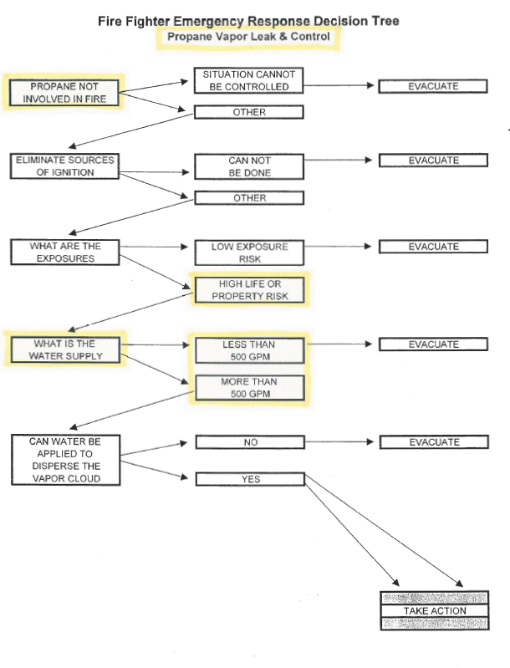

Propane Incident Response Decision Flowchart – on Fire
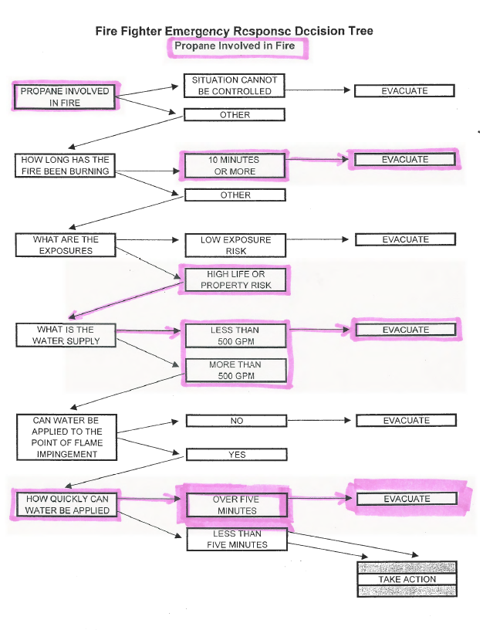

13. Termination of the incident Check List
- Assure that all hazards been stabilized
- Leak(s) plugged
- Is the area safe, hazard free?

2. Disposition of the Cargo
- If the equipment is intact and in a safe condition, can it be hauled away?
- If necessary to off load the material, equipment and appropriately trained personnel will be needed at the site
- If the product must be disposed of on site (safely), technical personnel must be provided to perform this operation.
- Liquid must be directed to a safe location and all leak precautions and procedures must be in place.
- Vapor spread shall be continuously monitored and security shall be maintained thru-out the operation.

3. Removal of damaged equipment/containers
- All equipment, trailers, tanks, etc. shall be safely removed using the safest methods available including any of the following equipment:
- tank trucks
- flat-bed trailer
- cranes, high-lift bags

14. Post Incident Critique
- Make notes as soon as possible following the termination of the incident of what went well, what did not work well
- What would you have done differently?
- Hold an incident debrief/critique with as many agencies that participated as soon as possible after the incident.
- Have someone summarize the comments and use them to modify this plan and other regional response plans.
- Share the comments with any agencies that might benefit from your experience.

