VERMONT EMERGENCY MANAGEMENT
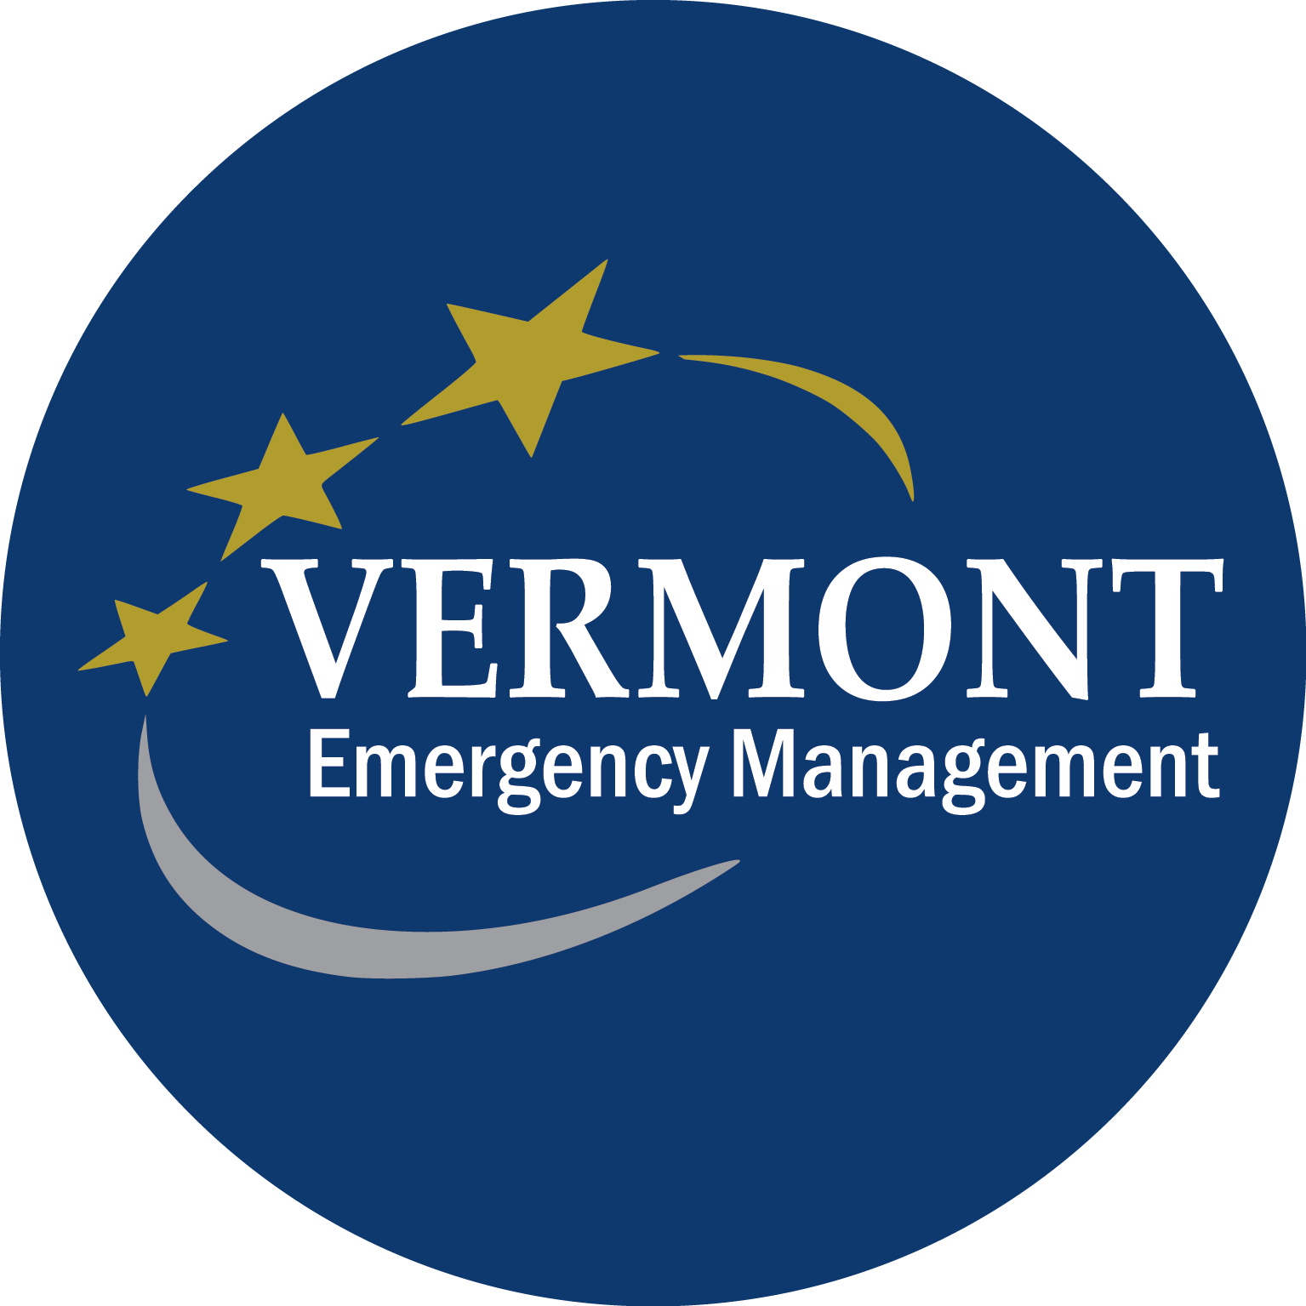
MEMORANDUM

TO: Vermont Regional Planning Commissions
FROM: Erica Bornemann, Director, Vermont Emergency Management
DATE: July 31, 2026
SUBJECT: Request for Proposals- Emergency Management Performance
Grant (EMPG) 2018 Regional Planning Commission Support
_________________________________________________________________________________

Overview:

Vermont Emergency Management (VEM) is seeking proposals to provide emergency management services at the local and state levels by the Vermont Regional Planning Commissions (RPCs). Funding will be provided by the federal Emergency Management Performance Grant.

RPCs may apply for up to $50,000 to complete work elements #1-4. Any proposed optional special projects (#5) will be assessed competitively and funded above the baseline scope elements and cost.

The priorities and eligible work items for each sub-grant are listed on the attachment named “EMPG 2018 RPC Scope of Work”. The sub-grant term will be from October 1, 2018 through September 30, 2019.

Application Requirements:

As part of the EMPG Application, all applicants will need to provide the following:

  - Complete EMPG 2018 Application:
The application must detail how each RPC proposes to complete the tasks in the Scope of Work and the cost associated. The budget must also identify the source(s) of 50% match requirement for these funds. Matches may be cash or documented third party in-kind time/services (provided these are for activities that would ordinarily be paid for under the grant), or other types allowed by 44 CFR 13.24. Indirect Costs are allowable only if there is a federally approved Indirect Cost Rate Agreement, and these charges must be separate from all hourly rates.

- A copy of your most recent organizational audit.

- A copy of your most recent Certificate of Insurance:
    - A copy of your Certificate of Insurance validating current insurance coverage.

    - Before commencing work on this Agreement, the Party must provide certificates of insurance to show that the following minimum coverages are in effect. It is the responsibility of the Party to maintain current certificates of insurance on file with the State through the term of the Agreement. No warranty is made that the coverages and limits listed herein are adequate to cover and protect the interests of the Party for the Party’s operations. These are solely minimums that have been established to protect the interests of the State.

Workers Compensation: With respect to all operations performed, the Party shall carry workers’ compensation insurance in accordance with the laws of the State of Vermont. Vermont will accept an out-of-state employer's workers’ compensation coverage while operating in Vermont provided that the insurance carrier is licensed to write insurance in Vermont and an amendatory endorsement is added to the policy adding Vermont for coverage purposes. Otherwise, the party shall secure a Vermont workers’ compensation policy, if necessary to comply with Vermont law.

General Liability and Property Damage: With respect to all operations performed under this Agreement, the Party shall carry general liability insurance having all major divisions of coverage including, but not limited to:
Premises - Operations
Products and Completed Operations
Personal Injury Liability
Contractual Liability
The policy shall be on an occurrence form and limits shall not be less than:
$1,000,000 Each Occurrence
$2,000,000 General Aggregate
$1,000,000 Products/Completed Operations Aggregate
$1,000,000 Personal & Advertising Injury

Automotive Liability: The Party shall carry automotive liability insurance covering all motor vehicles, including hired and non-owned coverage, used in connection with the Agreement. Limits of coverage shall not be less than $500,000 combined single limit. If performance of this Agreement involves construction, or the transport of persons or hazardous materials, limits of coverage shall not be less than $1,000,000 combined single limit.

Additional Insured. The General Liability and Property Damage coverages required for performance of this Agreement shall include the State of Vermont and its agencies, departments, officers and employees as Additional Insureds. If performance of this Agreement involves construction, or the transport of persons or hazardous materials, then the required Automotive Liability coverage shall include the State of Vermont and its agencies, departments, officers and employees as Additional Insureds. Coverage shall be primary and non-contributory with any other insurance and self-insurance.

Notice of Cancellation or Change. There shall be no cancellation, change, potential exhaustion of aggregate

The above is from Attachment C: Standard State Provisions from State of Vermont Bulletin 3.5, Procurement and Contracting Procedures, revised July 1, 2016.

- A copy of your approved indirect rate proposal.

- Quotes for equipment purchases (if applicable)
  - Equipment Quotes (if applying for equipment):
  - Three (3) quotes must be submitted for all single items valued at more than $100.00 per unit. Because the Code of Federal Regulations, 2 CFR part 225, requires full and open competition while procuring grant-funded equipment, a sub-recipient must obtain and provide multiple quotes for any equipment purchased with federal funds. Geographical preference and/or sole source will not be sufficient to comply with the competitive procurement requirements.
  - If (3) quotes are not provided, the applicant must explain the reason why three quotes were not submitted.
  - The applicant must indicate in their application the AEL# of any requested equipment.

- System for Award Management information:
Applicants must have a valid DUNS number and be currently registered with the System for Award Management (SAM) per the Federal Funding Accountability and Transparency Act (FFATA).

- Completed Financial Risk Assessment information:
To meet the Code of Federal regulations, the Vermont Department of Public Safety (DPS) requires all agencies to complete a financial risk assessment survey (https://www.surveymonkey.com/r/VTDPSrisksurvey). This should be completed by your agency’s fiscal agent annually.

- Procurement Policy
    - Organizations receiving funding must follow their own established procurement policies or revert to the State of Vermont’s procurement policy. The policy must be in writing and submitted to VEM. Procurement policies must conform to applicable Federal law and the standards identified in 2 CFR part 200:
(http://www.ecfr.gov/cgi-bin/text-idx?SID=289fd4edcc40f3b0cb6a4bd62aa39dbf&node=pt2.1.200&rgn=div5)

- Environmental and Historical Preservation
In order to facilitate any construction projects (equipment or facility), organizations should ensure they submit a FEMA Environmental and Historical Preservation (EHP) form. This form is required by FEMA to ensure there will be no adverse impacts to EHP for the proposed project. DPS will facilitate in the submittal of this form to FEMA, however, applicants must ensure they complete the form as best as possible. The form is found here: http://bit.ly/2wicIla

Program Reimbursement:

On a monthly basis, sub-grantees will need to submit with each reimbursement request:
- DPS Financial Report Form;
- Detailed supporting documentation (timesheets, payroll reports, general ledger reports, invoices, receipts, etc.);
- Any additional information to justify expenditures.

Application Details:
Applications will not be reviewed by VEM unless all requirements under “Application Requirements” are submitted and complete. Assistance in completing the application or additional questions can be forwarded to Erica Bornemann at 802-244-8721 ext. 5487 or erica.bornemann@vermont.gov.

Application Deadline:
All applications must be RECEIVED at the Vermont Emergency Management office by Close of Business on Wednesday, August 01, 2018. To facilitate processing, grant applications should be sent electronically to Marian Wolz at marianne.wolz@vermont.gov.

If you are unable to send your application electronically, you may mail it to the Department of Public Safety Grants Management Unit, 45 State Drive, Waterbury, VT, 05671-2101, however, it must be RECEIVED no later than the due date and time listed above.

Application Evaluation:

- Each application will be reviewed and scored based on the criteria outlined in the Scope of Work and quality of application details. Scores may be utilized to rank application funding and special project proposals. Applications should be submitted using the format provided, and should cover the following, for each scope element:

  - Task Description (multiple may be used for each scope element):
    - Description of work required for a task and how it will be accomplished.
  - Deliverables:
    - What will be accomplished through a task, as defined in the Reporting Requirements of the Scope of Work document.
  - Timeline and milestones:
    - Definition of milestones and overall timeline for the task.
  - Personnel
    - Names, position, and hours for each person required to complete the task.
  - Mileage
    - If necessary.
  - Cost
    - Cost per individual require to complete the task.

- VEM will review and score each application, to include all proposed work elements, and will make a funding decision based on the effectiveness of the application to increase statewide emergency management preparedness and response efforts.

